**Assignment-2**

1. Write a program to enter basic salary, DA (in %), HRA (%) and calculate the gross salary. Also calculate the tax payable on the above entered data as per the following criteria.

Gross Salary Tax

Less than 3lacs NIL

3 lacs to 5 lacs 10% of the exceeded amount More than 5 lacs 15000 + 30% of the exceeded amount

Test your program at least once for each case given above.

Answer:

Code for the program:

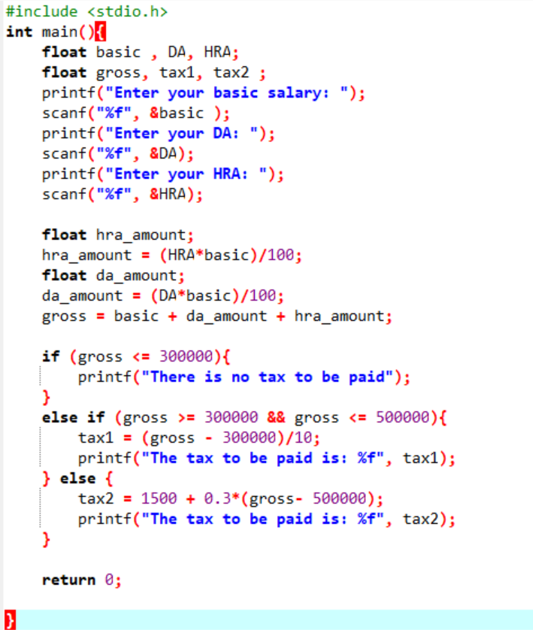

Outputs for the programs:

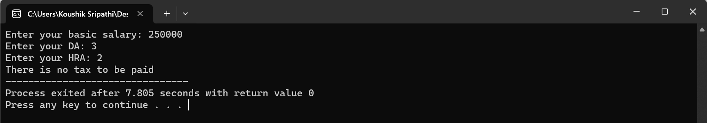

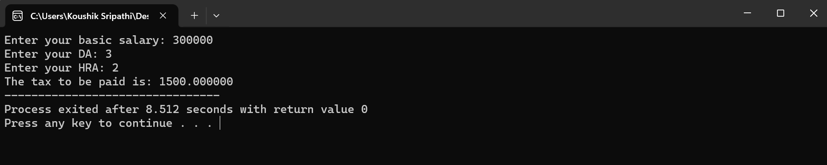

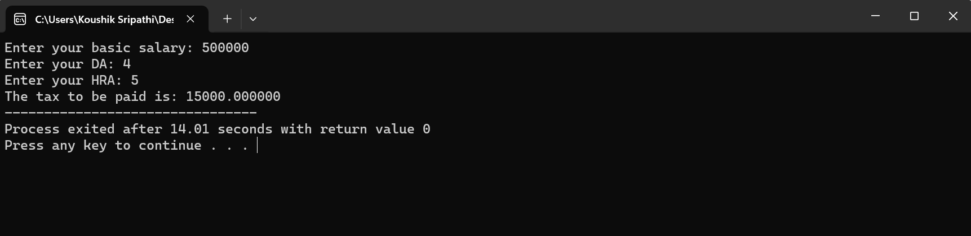

1. Write a menu-driven program in C, in which when the user enters a number it will ask the user to enter a choice

1) ‘p’ for checking whether the number is prime or not,

2) ‘f’ for displaying all the prime factors of user entered number,

3) ‘d’ for displaying all the prime numbers, before user given number,

4) ‘e’ for exit from the program and all other choices should display the wrong choice.

The program should operate according to the submitted choice.

ANSWER:

CODE FOR THE PROGRAM:

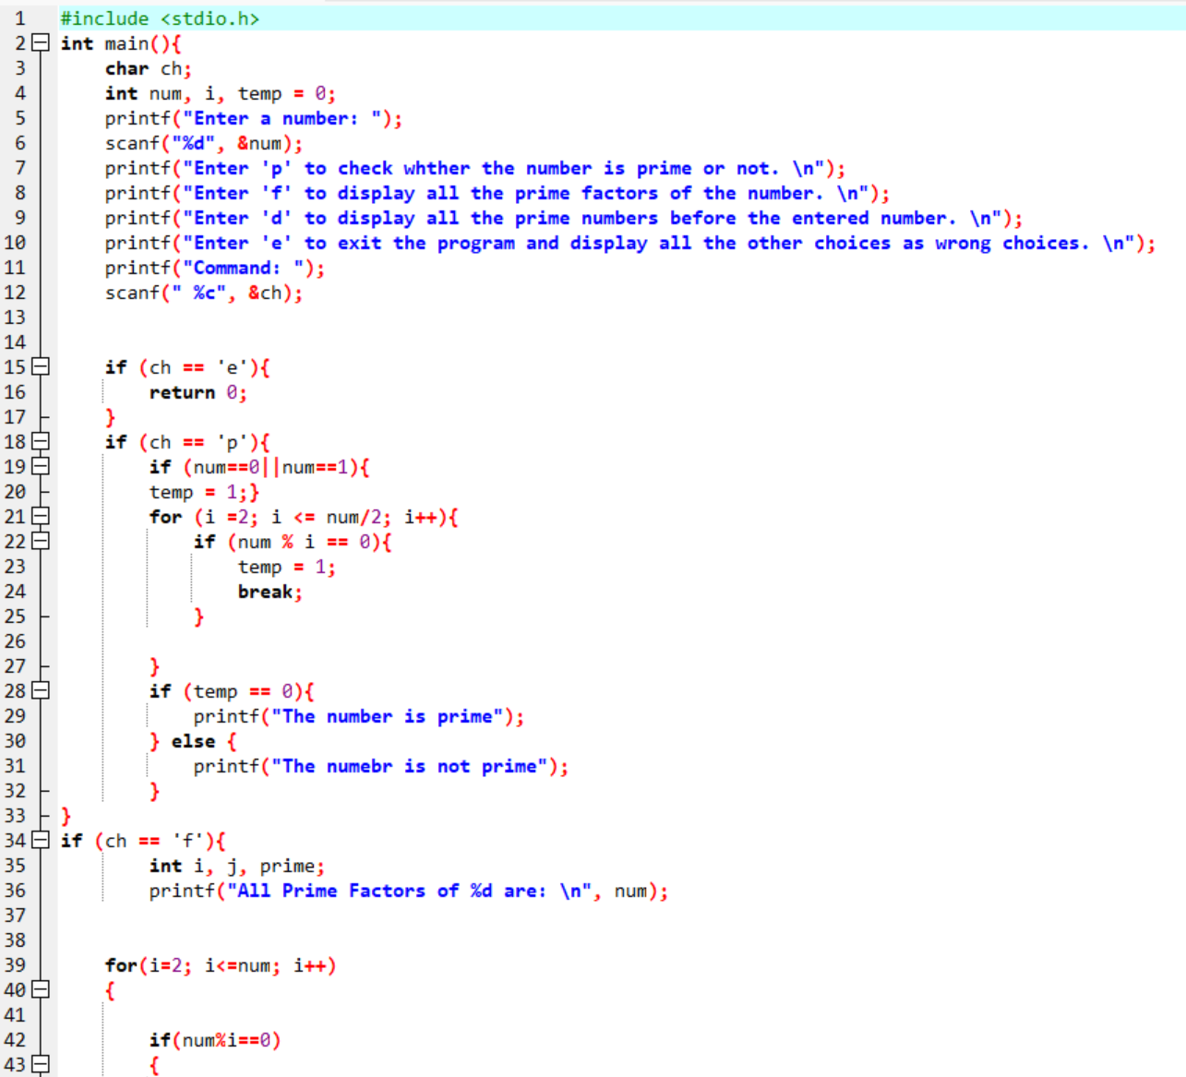

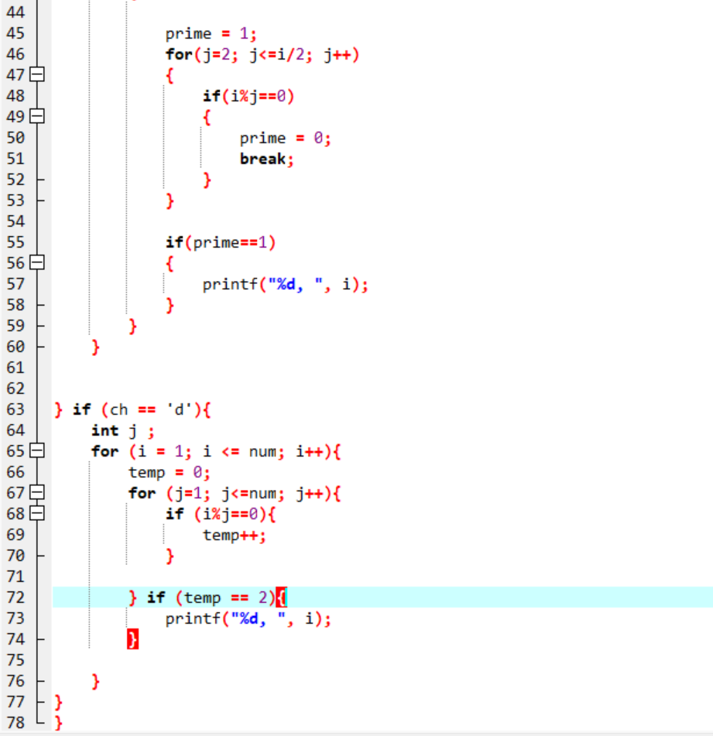

OUTPUTS OF THE PROGRAM:

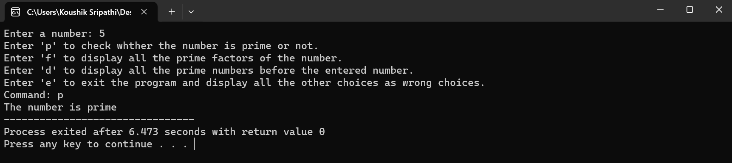

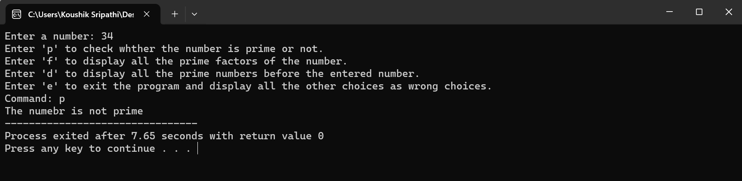

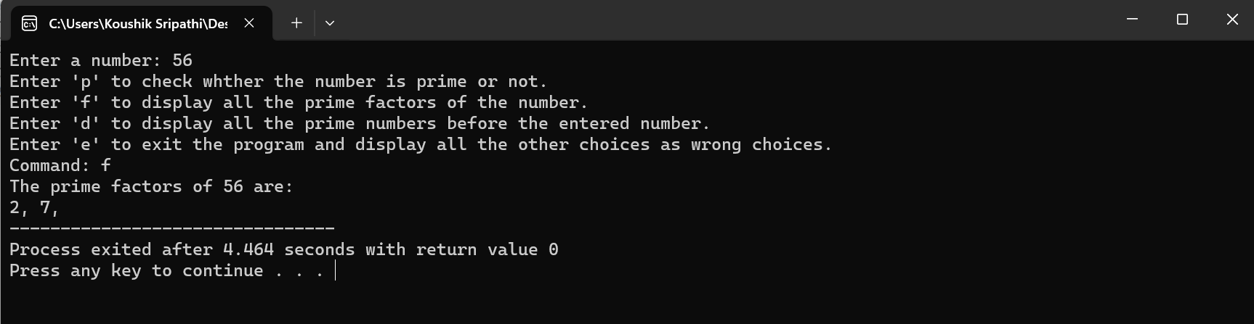

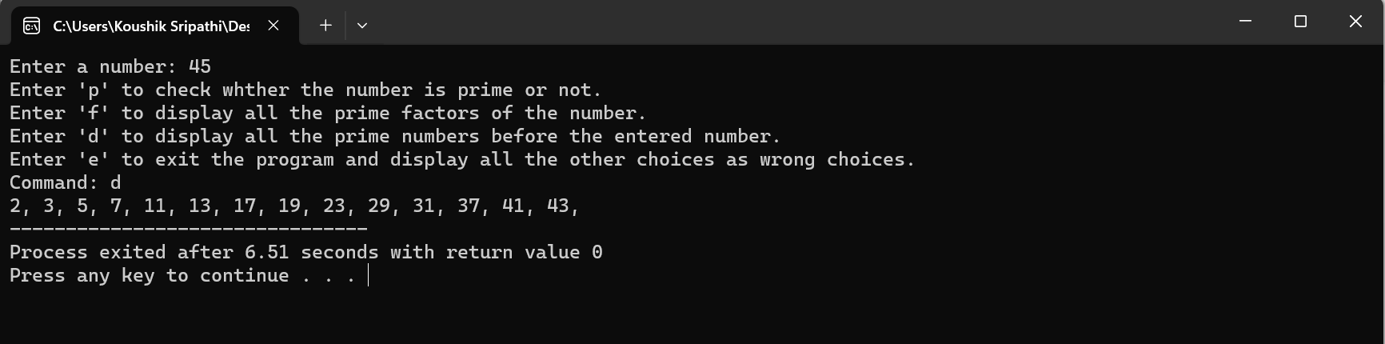

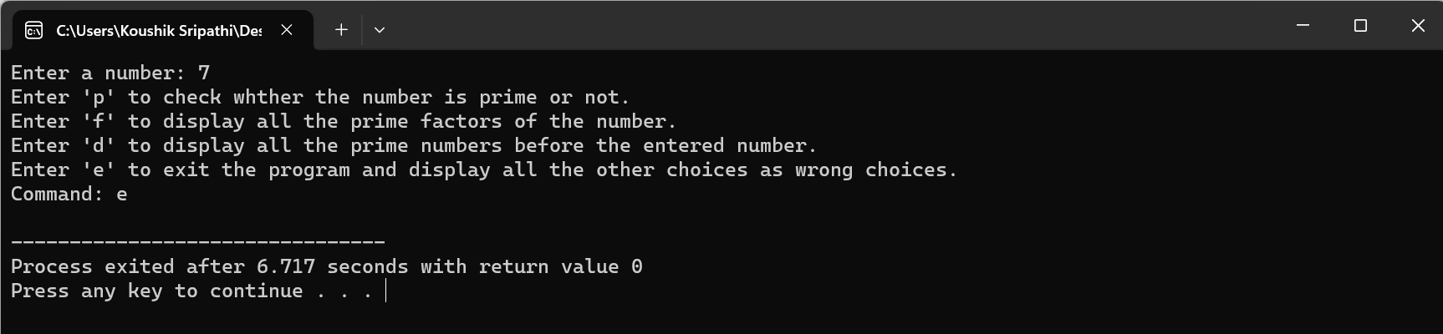

1. WAP to print the Pascaline triangle as shown below:

*

**

***

****

*****

ANSWER:

Code for the program:

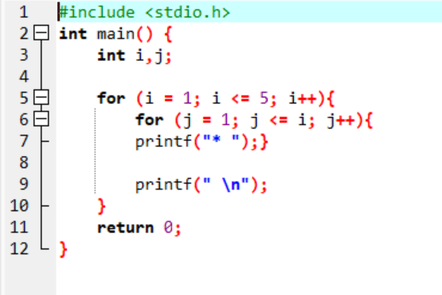

Output of the program:

